**Ideation Phase**

**Brainstorm & Idea Prioritization Template**

|  |  |  |  |
| --- | --- | --- | --- |
| Date | |  | | --- | |  |  |  | | --- | | 28 May 2025 | |
| Team ID | LTVIP2025TMID33353 |
| Project Name | HealthAI: Intelligent Healthcare Assistant Using IBM Granite |
| Maximum Marks | 4 Marks |

**Brainstorm & Idea Prioritization – HealthAI Project**

Brainstorming and idea prioritization is a crucial step in the ideation phase of our **HealthAI – Virtual Health Assistant** project. It helps the team collectively generate creative, relevant, and impactful ideas to solve the key problem:

“How might we provide rural and semi-urban individuals with quick, accurate, and accessible health advice and support using AI, without the need for visiting a physical clinic?”

During the session, our team followed a structured process to explore all possible features, tools, and technical solutions that could address this issue. We used virtual sticky notes, grouped similar ideas into themes, and placed them on an **Impact vs. Feasibility Grid** to identify which ones to prioritize for development.

**Step-1: Team Gathering, Collaboration and Select the Problem Statement**

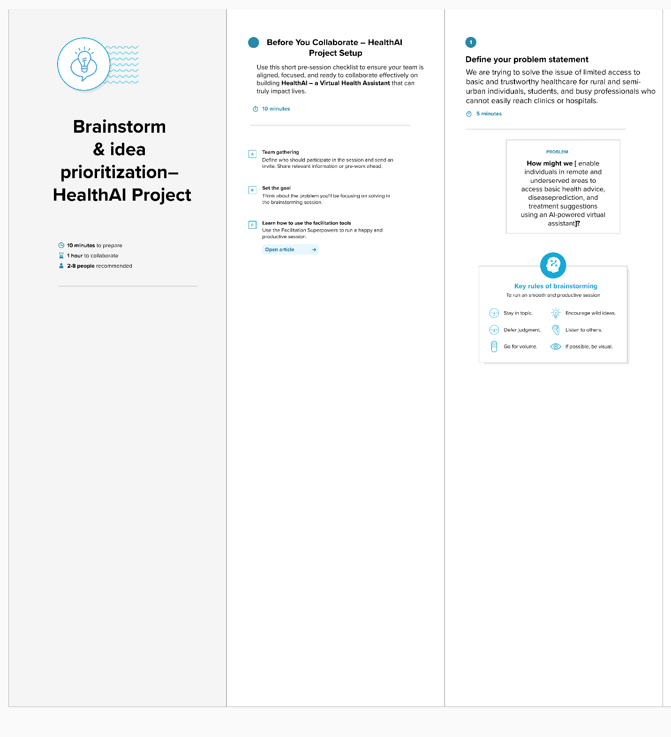

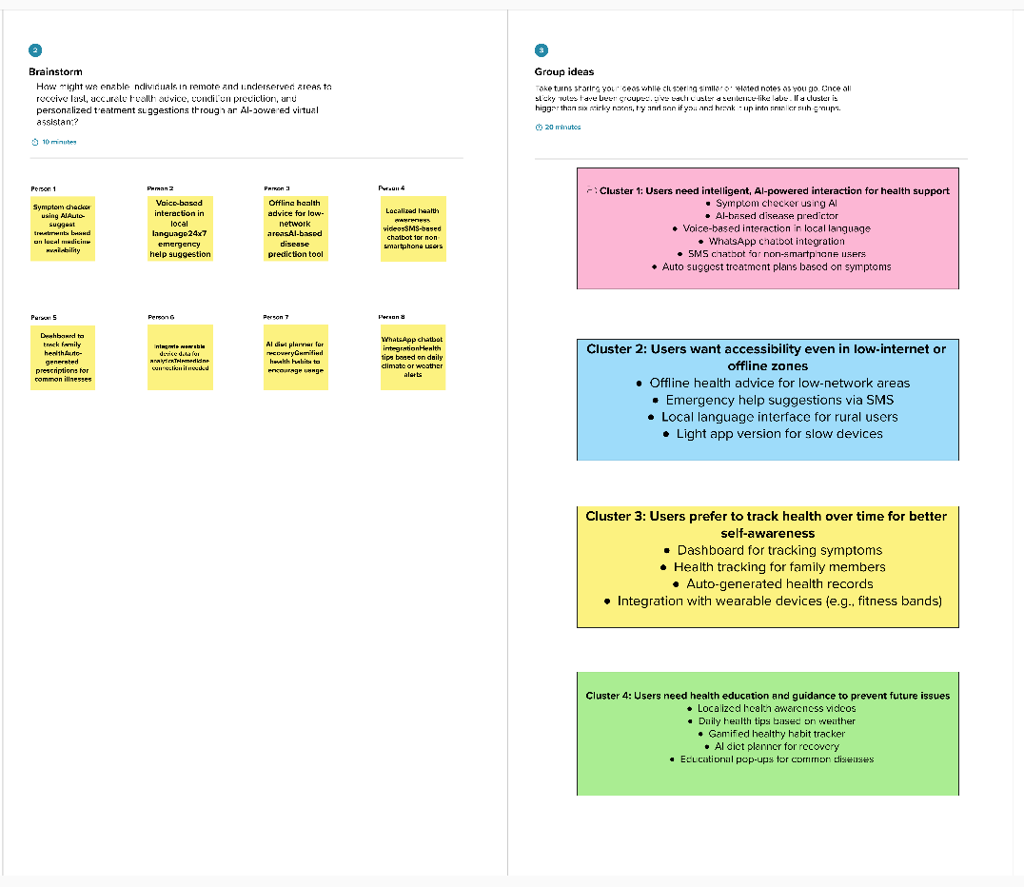**Step-2: Brainstorm, Idea Listing and Grouping**

**Step-3: Idea Prioritization**

